Repairs Intervention Policy

Document owner | Matthew Rothwell – Director of Asset Management
Approved by | Executive Team
Approved date | TBC
Review date | TBC
Version | V1
Policy reference | RG AM21

Introduction

1.1 This policy is designed to implement a data driven, pro-active response to drive strategic decisions and provide an improved service delivery for our customers and property portfolio.

1.2 This will involve identifying key indicators around trends in regions and areas, specific repair types, as well as providing methods to flag an early risk of remedial work, the mitigation of legal disrepair cases, and improve overall property performance. This will align with our customer centric values and work toward achieving a better insight into the customer, to build relationships, trust, and engagement. Through improved collaboration with other parts of the business this will help drive improvement of the customer experience.

1.3 This analytical approach to data is essential for the Group to greater understand its customers and will be used to steer improvements on the methods used in engaging with our customers, understanding what is happening in our customers’ homes and supporting access to customers homes to undertake statutory compliance measures.

1.4 After analysis of the associated datasets specific to the subject area, the indicators in the data will dictate the level and method of intervention, with findings presented to the relevant business area to deliver.

1.5 The Social Housing sector has produced recent reports and new standards which have shaped the data usage model and approach of this policy. Any future publications or legislative changes will be assessed, and the data model adjusted to incorporate additional datasets where necessary.

1.6 This policy therefore focusses on a standardised strategy and protocol, were possible, setting out certain criteria that indicates the review process. This will be driven by components such as geographical location, the type and frequency of repairs, property archetypes and will detect areas for intervention. This will begin with an analysis of our core service areas of delivery and look to conjoin the asset management function with the values of the business and external influences surrounding the sector. It is important to detail that this policy is the responsibility of stakeholders across the Group to deliver.

1.7 This is a process that will be regularly monitored to align with any legislative or regulatory developments within the social housing sector in addition to our own working practices and business decisions. We reserve the right to take a different approach.

Definitions

2.1 This Intervention Policy will ensure Regenda Homes maintains its’ stock to a standard to meet customer needs and regulatory requirements, whilst provide a greater understanding of our customer base to ensure they live in homes that are safe, secure, affordable, and free from extensive repair.
2.2 It will also actively feed into the Groups’ business plan by providing, where necessary, informed decisions to advance component replacements due to component or building defects. This will ensure the business has recent, reliable and accurate data that not only takes into account cyclical lifecycles but also provides a more realistic lifespan where the component or building is defective. *A Business Plan is a financial forecasting tool identifying component replacements over a 30-year period.
2.3 The policy should utilise technology interfaced with our core housing management system to ensure a holistic approach to our asset management function(s), influencing improvements to service delivery and engagement with our customers. The review and analysis of data held within our Asset Management system(s) will be used to determine the level of intervention and to identify associated trends.

2.4 InPhase is a business management tool used to monitor and report on performance indicators, displayed through a suite of dashboards. As the groups singular reporting tool it ensures transparency in reporting and data quality management through its range of reports. Examples of the InPhase software is included within section 11 of this policy.

Scope and exemptions

3.1 This policy applies to all properties owned and managed by Regenda Homes Limited, targeting statutory and regulatory requirements as a social landlord.

Approach to Intervention

4.1 Approach to Data Analysis & Reporting Techniques

4.2 This section will outline some of the criteria for producing datasets, the level and to the type of intervention proposed. It will help provide a greater understanding of the potential options available before measures are undertaken. This approach will alternate on review of the data and evolve in line with deliverable outcomes achieved.

4.3 Data Usage Model

4.4 The use of on-going analysis of varying datasets from within the wider Asset Management function to help dictate scope of intervention and associated trends within the subject area. The Groups’ core reporting tool, InPhase Reporting Suite, will be a key driver to interpret the information of both stock and repairs analysis. An array of variables will be used to analyse both property and repairs information to form trend analysis and presentable data.

4.5 All datasets will incorporate the following set criteria to identify trend analysis and intervention hotspots and/or indicators:
- UPRN
- Address details
- Street
- Postcode
- Build-year
- Ward
- Local authority
- Region

4.6 Stock Profile

4.7 The profile of the Groups’ stock is an essential dataset that forms part of the decision-making process for the level of intervention or potential strategy undertaken. The profile relates to key characteristics of a property such as, but not limited to, wall construction type, roof construction type, construction year and geographical location. Using the above dataset, outlined within section 4.5 of this policy, and data around the property profile, the data will then be overlayed with specific repairs and/or investment information to identify associated trends and measures of intervention.

4.8 Analysis will be undertaken to review potential property defects or specific geographical repair trends that will influence investment planning and improvement works.

4.9 On occasion, this process may identify several properties that the Group wishes to dispose of in-line with the Asset Disposal Strategy.

4.10 Void Analysis

4.11 The analytical approach to voids will be undertaken to understand the level of repairs and costs following a re-let to a property, reporting over a 12-month period. The purpose of analysing current and recently void properties will provide a greater chance of mitigating the risk of disrepair and allow the business to make more informed decisions on stock retention or disposal.

4.12 The below dataset will be utilised to supplement the criteria set out in section 4.5 of this policy.

- Subsequent repair trends following a re-let of a property.
- Subsequent repair costs following a re-let of a property.

4.13 In addition to this, the information that will be presented will allow the wider business to focus on void termination reasons, neighbourhood performance and utilise this to improve tenant sustainability.

4.14 It is recommended that the use of smart technology in a percentage of void properties that have identified issues pertaining damp and mould to prevent repeat repairs and increase customer engagement.

4.15 Disrepair Analysis

4.16 One of the key areas of repair intervention is to mitigate the risk of properties falling into a state of disrepair, targeting geographical areas in advance to prevent cases and claims against the business. Analysis of the data around disrepair will be used in conjunction with the property archetype to determine trends in the profile of stock susceptible to a possible disrepair claim. This intervention process will reduce spend on legal costs and customer compensation, whilst ensuring homes are fit for habitation.

4.17 The use of the overlaying dataset below will present the associated intervention measures to be undertaken. It will also determine at what stage this will be implemented, such as upon receipt of a claim, during or after completion of the claim.

- Number of live disrepair cases.
- Review of historic Disrepair cases
- Disrepair cases by location.
- Legal costs expenditure.
- Compensation cost expenditure.
- Dropped case numbers and forecasted average cost saving.
- A review of cancelled jobs against the property and how this may impact any current or future complaints.

The type of potential intervention measures to be undertaken on review of the data:

- Targeted written communication to customers via location trend.
- Increase customer engagement post-claim, contacting the customer at 3-month, 6-month and 12-month periods.
- Undertake a review of each property that has been through a disrepair case within a 12-month period, scrutinising post-claim repairs.
- Reinstatement of cancelled works orders that may still be outstanding.

4.18 It is recommended that the use of smart technology in a percentage of properties that have had a disrepair claim can be utilised as a tool to monitor future repair issues and possible repeat claims.

4.19 Repair & Adaptation Analysis

4.20 The repairs dataset will be the largest area and data to review and formulate appropriate levels of intervention. The analysis of this data will be broken down into the following topics and intervention measures and will be overlayed with property archetype and geographical data to enhance the analysis:

- Multiple repairs, focussing on properties that have a large number of repairs raised in a 12-month period.
- Low-level repairs with no recent history of any major works or component replacements having taken place.
- Subject related repeat repairs – such as, but not limited to Roof leaks, Anti-social behaviour, Pest related works.
- A review of any repairs related specifically to Damp, Mould and Condensation.
- A review of cancelled jobs against the property and how this may impact any current or future complaints.
- A review of repairs and any repeat repairs to adapted properties, considering cost implications around specialised equipment.

The type of potential intervention measures to be undertaken on review of the data:

- Inform Asset Strategy team to expedite properties onto associated investment programmes of work.
- Contact the customers proactively via written communication and/or telephone to understand their circumstances and repair requirements, if any.
- Add the property to the stock condition surveying programme to have full property assessment.
- Inform Asset Delivery team to target “at risk” properties for survey and facilitate repair works where possible.
- Liaise with Neighbourhood and Tenancy Management teams to increase engagement and access to the property.
- Work with internal and external stakeholders to resolve complex cases/issues.
- Recommend the installation of smart technology.
- Reinstatement of cancelled works orders that may still be outstanding.

4.21 On review of the data, where a customer has had minimal or no level of repairs reported or engagement over a 12-month period, then the following approaches will be undertaken, where necessary.

- Contact customer(s) via telephone and written communication.
- Liaise with the Neighbourhood and Tenancy Management team for assistance with engaging with the customer(s) to increase engagement and access to the property.
- Work to ensure customers are signposted correctly and any safeguarding concerns raised, identifying if individual support needs are required, in line with organisational and legislative procedure.

4.22 Hard-to-Access Properties

4.23 Increasing the level of engagement with customers is pivotal to providing a greater understanding of who they are and accessing their homes to assess the condition and standard of the home they’re living in.

4.24 Datasets produced will be used in the following priority order to proactively engage with our customers.

- Properties with no repairs reported since their last gas service or within a 12-month period, that have externally capped meters.
- All electric properties with no repairs reported within a 12-month period. since their last fixed-wire test.
- Externally capped properties with minimal repairs since their last gas service.
- All electric properties with minimal repairs within a 12-month period.
- Properties that have had their gas service or electrical fixed-wire test completed with 2-weeks or less before expiration date.

  - On review of the data the following measures and intervention will be implemented:

- Work with neighbourhood team for assistance with engaging with the customer(s).
- Working with external stakeholders to ensure access is gained on any complex cases/issues.
- Index of Multiple Deprivation dataset used as an indicator to determine potential customers and properties “at risk” or in-need of additional support measures.
- Increased customer contact via telephone and written communication.
- Highlighting any safeguarding risks or vulnerable customers for support.
- Review of property energy data and SAP ratings for potential improvements in property performance and efficiency.

  - Housing Health & Safety Rating System (HHSRS)

4.27 As part of our stock condition process, the HHSRS system (Housing Health & Safety Rating System) is used to identify Category 1 and 2 hazards within our properties. Category 1 hazards are sent by our surveying company urgently upon receipt of these and Regenda Homes effectively track these through to completion. Category 2 hazards are provided at intervals throughout the process of the stock condition programme.

The below dataset will be overlayed with property archetype and geographical data to understand:

- Repair trends of a Category 1 and/or 2 hazards.
- Review properties that have identified multiple HHSRS hazards following stock condition survey.
- Repeated HHSRS hazards identified via different channels. Training of internal property surveyors in HHSRS and stock condition surveys will allow greater frequency in data being received.
- Properties with multiple repairs criteria; HHSRS hazards, disrepair cases, damp mould and condensation issues, or major works undertaken previously.
- A review of cancelled jobs against the property and how this may impact any current or future complaints.

4.28 The type of potential intervention measures to be undertaken on review of the data:

- Review of outstanding repair and investment works associated with a property that has received a category 1 and/or 2 hazard.
- Targeting similar profile of stock to that where a category 1 or 2 hazard has been identified to mitigate future risk of this elsewhere geographically.
- Create appointment for repairs surveyors to attend to the property to identify wholesale repairs.
- Contact customer(s) via telephone and written communication.
- Liaise with the Neighbourhood and Tenancy Management team for assistance with engaging with the customer(s) to increase engagement and access to the property.
- Work to ensure customers are signposted correctly and any safeguarding concerns raised, identifying if individual support needs are required, in line with organisational and legislative procedure.
- Reinstatement of cancelled works orders that may still be outstanding.

4.29 Complaints Analysis

4.30 First stage complaints provide an insight into the customer, and an opportunity to understand some of the issues they are experiencing in their homes or services being provided. Aligned with the Groups’ values around customer centricity, exploration of common or repeat themes for complaints received within a 12-month period will be used to implement associated intervention measures and making informed decisions around improvements for the customer experience and the homes they live in.

In addition to the use of the existing datasets, collation of the data detailed below will be used to reduce repeat issues or complaints being officially lodged:

- Number of complaints.
- Complaints by location.
- Trend of the types of complaints being lodged.
- Cost expenditure of repairs and/or investment works on complaint property in a 24-month period.
- Customer compensation expenditure on complaints.
- Multiple complaints over a 12-month period to identify repeat contributing factors.
- Complaints that have been escalated to the Housing Ombudsman or escalated to disrepair cases.
- A review of cancelled jobs against the property and how this may impact any current or future complaints.

4.31 The type of potential intervention measures to be undertaken on review of the data:

- Proactively working to target similar profile of stock where repeat issues around complaints have been logged.
- Reinstatement of cancelled works orders that may still be outstanding.

4.32 Smart Technology

4.33 The Housing Sector is constantly evolving and working with external providers through the installation of smart technology within our homes can be an essential route to take to proactively monitor different facets of stock performance and customer engagement. A fully costed strategy will be devised to implement smart technology where necessary to assist with the development of the Groups approach to intervention.

4.34 Retrofit and Decarbonisation of Properties

4.35 From time to time, some of the intervention measures may result in undertaking retrofit and fabric first improvement measures to assist in mitigating risks highlighted within this policy.
This may require exploring possible funding streams and understanding the wider position faced to reach industry targets set by the Government.

4.36 Internal Process

4.37 The internal control process to intervention is key in the delivery of the measures outlined within this policy. A “Repairs Intervention Working Group” will meet monthly to present data, trends and findings, to enable the measures to successfully mitigate future risks outlined within this policy. The steering group will work on the sectors challenges facing the Regenda Group, ensuring customer centricity, increased customer engagement and improving customer satisfaction.

Associated documents

5.1 Associated legislation, regulation, and guidance

Associated legislation, regulation and external standards
Ombudsman Spotlight Reports
Decent Homes Standard
Proposed Consumer standards
Social Housing White Paper
Social Housing Regulation Bill
Better Social Housing Review
Knowledge and Information Management Report

Associated Regenda Homes / Group documents / guidance
This should include any internal documents that may be referred to or sit alongside this policy, this may include any processes, guidance notes and system user guides.

Associated Regenda Homes / Group documents / guidance
Asset Management Strategy
Investment Policy
Repairs Policy
Asset Disposal Policy
Void Policy

6. Equality, diversity, and inclusion

6.1 Equality, Diversity and inclusion will be taken into consideration when any assessments or possible action are taken, in line with the group stance and regulatory requirements on this.

7. Data Protection

7.1 Any personal data collected or shared as part of this policy will be subject GDPR guidelines, in any event where personal data is to be shared externally a Data Sharing Agreement will be entered into and Governance Team consulted with beforehand.

8. Monitoring and reporting

8.1 Any determinations from the intervention and analysis will be subject to approval by senior management and passed onto the relevant part of the business in line with any strategic aims, or budgetary impact for that department.

Amendment log

Change | Made by | Authorised by | Effective date

- Appendix

11.1 Below are examples of the InPhase reporting software which will be used to analyse all associated data outlined within this policy. The software provides great visualisation and has access to supporting data for further analysis to be undertaken.

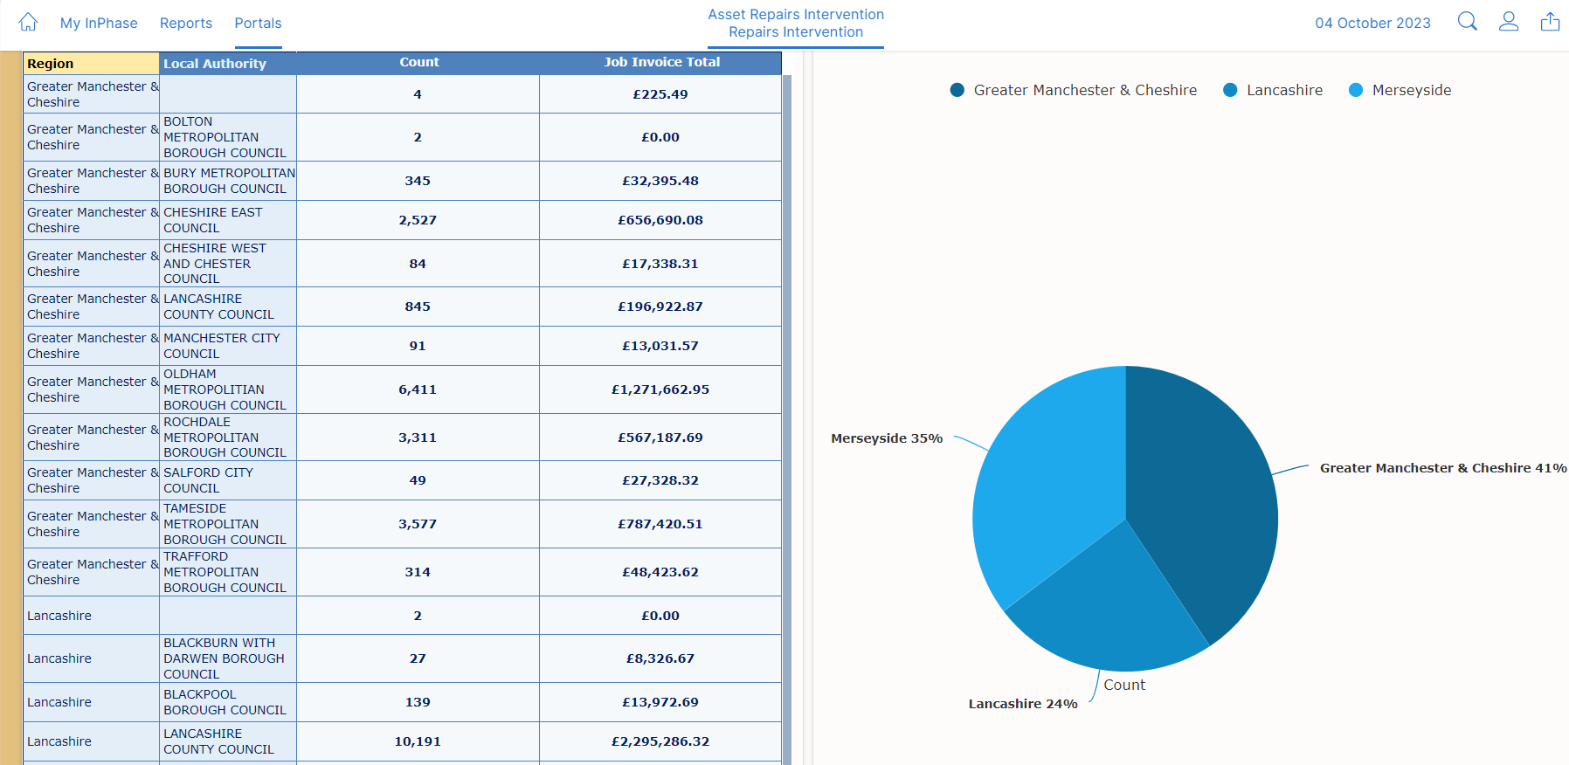

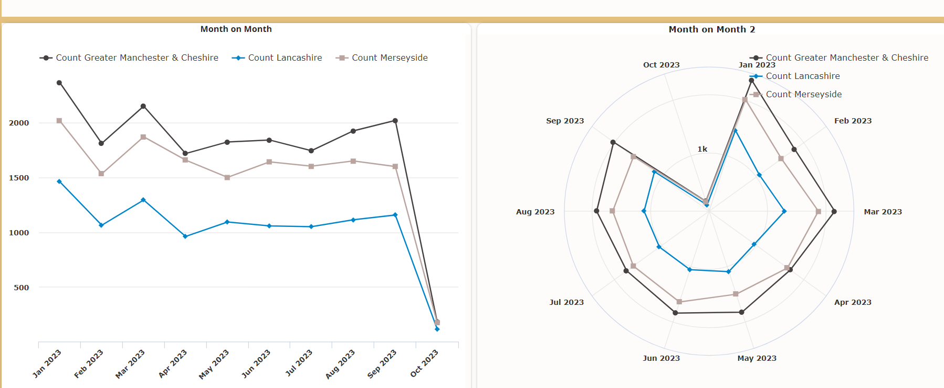

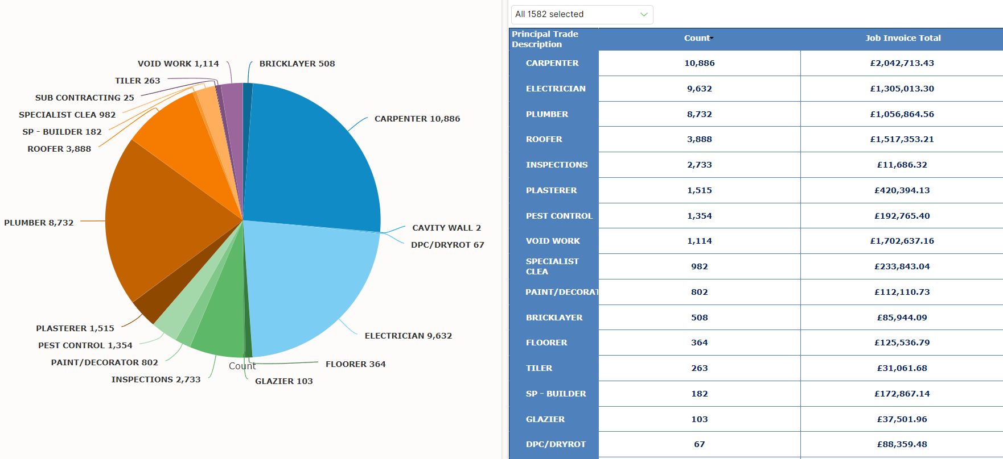

  - Below are examples of the InPhase reporting software extract that will allow analysis to be undertaken in finer detail in accordance with the data usage model outlined within this policy.

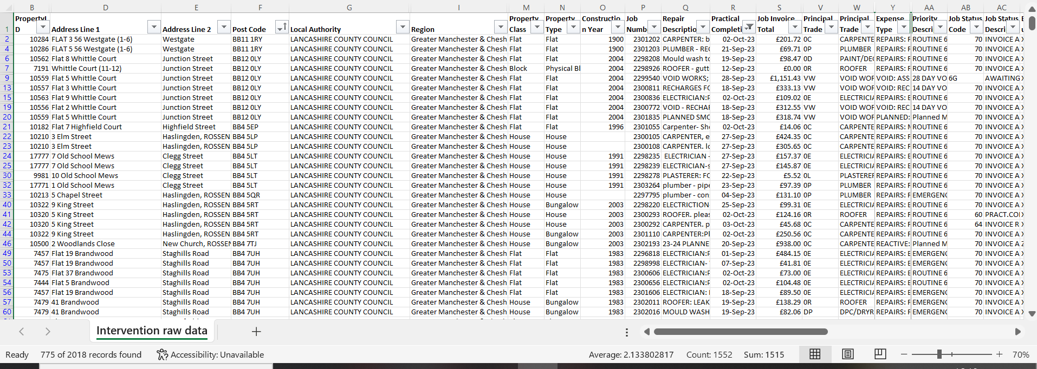

Area | Category | Measure | Frequency
Multiple repair transactions | Multiple repairs, focussing on properties that have a large number of repairs raised in a 12-month period. | Top 10% | Annual
Multiple repair transactions | Monthly check of multiple repairs that exceed warning level. | 20 - repairs in rolling 12 month period | Monthly
Multiple repair transactions | Monthly check of the same SOR (x3) and same trade (x5) at individual property level within a 6 month period. | Same SOR code within a six period. | Monthly summary and qtr summary to Board and Executive.
Multiple repair transactions | Monthly check of the same SOR (x6) and same trade (x10) for all communal areas within a 6 month period. | Same SOR code within a six period. | Monthly summary and qtr summary to Board and Executive.
Multiple repair transactions | Monthly check of any damp, mould or condensation repair that exceeds 3 in a rolling 6 month period. | > 3 damp and mould or condensation repairs within a 6 month period. | Monthly summary and qtr summary to Board and Executive.
Multiple repair transactions | Monthly check of subject related repeat repairs – such as, but not limited to Roof leaks, Pest related works etc raised in a 6 month period > 5. | > 5 subject related repairs within a 6 month period. | Monthly summary and qtr summary to Board and Executive.
Multiple repair transactions | Monthly check of multiple emergency repairs within a rolling 12 month period >5 | >5 emergency repairs | Monthly summary and qtr summary to Board and Executive.
Inactivity | All electric properties that havent had a repair carried out by M&Y within a 12 month period. | All electric properties with no repair within 12 month period. | Annual summary to ET and Board.
Inactivity | 3 or more no access of the same trade in a rolling six month period. | 3 or more no accesses of the same trade. | Monthly summary and qtr summary to Board and Executive.

